PRIMAL RESEARCH IDEAS IN SCIENCE AND MANAGEMENT PRISM – 2022

IDEA PROPOSAL APPLICATION

Early Detection of Sleep Deprivation: Impact on Cognitive Performance Using Deep Learning Techniques

# Title:

**Category:** Please tick the appropriate category

|  |  |
| --- | --- |
| Student (UG/PG from any discipline) |  |
| Researcher (Ph.D. students/staff from research organizations) |  |

**Author(s) and affiliation: (Maximum 5)**

|  |  |  |
| --- | --- | --- |
|  | Harsha K.G. | PG Scholar (Master in Data Science) Department of Statistics and Data Science  CHRIST (Deemed to be University), Bangalore |
| 7593974960 | [harsha.kg@msds.christuniversity.in](mailto:harsha.kg@msds.christuniversity.in) |
| 2 | M. Madiha Farhana | PG Scholar (Master in Data Science) Department of Statistics and Data Science  CHRIST (Deemed to be University), Bangalore |
|  | 8555963051 | [m.farhana@msds.christuniversity.in](mailto:m.farhana@msds.christuniversity.in) |
|  | Joan Jose M | PG Scholar (Master in Data Science) Department of Statistics and Data Science  CHRIST (Deemed to be University), Bangalore |
|  | 9645276142 | [joan.m@msds.christuniversity.in](mailto:joan.m@msds.christuniversity.in) |
|  | Keerthana R | PG Scholar (Master in Data Science) Department of Statistics and Data Science  CHRIST (Deemed to be University), Bangalore |
|  | 9384960246 | [keerthana.r@msds.christuniversity.in](mailto:keerthana.r@msds.christuniversity.in) |
|  | Aiswarya Antony | PG Scholar (Master in Data Science) Department of Statistics and Data Science  CHRIST (Deemed to be University), Bangalore |
|  | 8086676496 | [aiswarya.antony@msds.christuniversity.in](mailto:aiswarya.antony@msds.christuniversity.in) |

**Mentor details: (if any)**

|  |  |  |
| --- | --- | --- |
| 1 | Sibu Cyriac | Senior Programme Manager Centre of Digital Innovation  CHRIST (Deemed to be University), Bangalore |

# Declaration: Click on the box to tick

|  |  |
| --- | --- |
|  | I/We hereby confirm that author/s are students (UG/PG/PhD) or research scholars working in non-profit organizations and ready to provide a valid proof for the same at any time. |
|  | The submitted idea is not have been previously presented/published or submitted for consideration elsewhere. |
|  | I/We hereby declare that I/we read and accept all the terms and conditions. |

**What scientific problem are you trying to solve?**

Decision-making falls under the broader category of executive functions, often called cognitive performances, including working memory, learning and implementation, automatic responses, and probabilistic assessment. Performing these day-to-day tasks can be a challenge for people with sleep deprivation. A standard theory suggests that attention is the only cognitive function affected by sleep deprivation; cognitive impairments can also be mediated through alertness during sleep, slowed responses, and wake state instability. Our study proposes to examine the neural and cognitive changes associated with sleep deprivation using Deep Learning algorithms. A study examining the neural changes during sleep deprivation can provide critical information on the brain’s ability to perform decision-making tasks to reveal significant cognitive consequences.

Until recently, most automated pattern recognition tasks, such as sleep staging, have relied on rule-based computer programs, which are vulnerable to human error and bias. The models which used Machine Learning, Regression, and Classification showed an average accuracy of 80% (Automatic and Accurate Sleep Stage Classification via a Convolutional Deep Neural Network and Nanomembrane Electrodes, 2022) (Prediction Models for Obstructive Sleep Apnea in Korean Adults Using Machine Learning Techniques, 2021) (Machine Learning Models for the Classification of Sleep Deprivation Induced Performance Impairment During a Psychomotor Vigilance Task Using Indices of Eye and Face Tracking, 2020), and the model, which was used by MIT (Massachusetts Institute of Technology) to predict sleep disorders or stages of sleep using radio waves, has shown 70% accuracy or less; (Learning Sleep Stages from Radio Signals: A Conditional Adversarial Architechture, 2017) in some cases, the models couldn’t perform well and didn’t give accurate results due to incorrect data recording. While reducing our subject’s time frame in which the activities would be recorded, signs of sleep disorder can be predicted, which wouldn’t hinder the ability to perform cognitive activities. The data can be collected through a Polysomnography (PSG) test (Artificial Intelligence and Sleep: Advancing Sleep Medicine, 2020) consisting of ECG (electrocardiogram), EEG (electroencephalogram), EMG (electromyogram), and EOG (electrooculogram). Combining the classification stages of sleep with this data to predict the quality of cognitive performance can help clinical care detect sleep disorders early and improve cognitive performance.

# Outline your idea

Computational advances now enable computers to recognize patterns within data without requiring explicitly programmed rules and AI approaches such as deep neural networks, which receive a set of inputs and perform progressively complex calculations on their promise to provide new insights to inform diagnosis and clinical care of sleep disorders in the form of classification.

Analyzing the signals emitted through the subject’s body movements can be monitored, and the measures can be translated into types of sleep stages, i.e., light, deep, and rapid eye movement (REM); this method is known as Sleep Stage Scoring or classification. Cognitive functioning refers to the mental abilities which include learning, reasoning, problem-solving, attention, and decision-making. Our study is limited to 18 – 25 years as people under this age group are more vulnerable to sleep disorders. AI uses a combination of raw and featured data; in our case, the analysis would include only featured data. The data collected through the Polysomnography test will evaluate the whole body’s movements. The data is collected through leads on chest ECG, leads on forehead EEG, measures of electric currents generated through muscles EMG, and EOG for the movements of eyes.

Machine Learning and Deep Learning approaches have attracted attention in recent years for classifying sleep stages with the availability of deep learning techniques. With this, we will try to evaluate cognitive performance to recommend a personalized diagnosis.

# Provide possible outcomes for a new idea

* Enable clinicians to provide personalized recommendations frequently based on the interpretation of the data collected through changes in sleep patterns.
* Expected to provide new insights to inform the clinical care of sleep disorders and advance our understanding of sleep’s integral role in human health.
* Streamlining day-to-day operations and optimizing direct patient care, focusing on treatment outcomes.
* Simplify sleep disorder diagnosis by increasing patient services, making it cost-effective.

**Additional Details:**

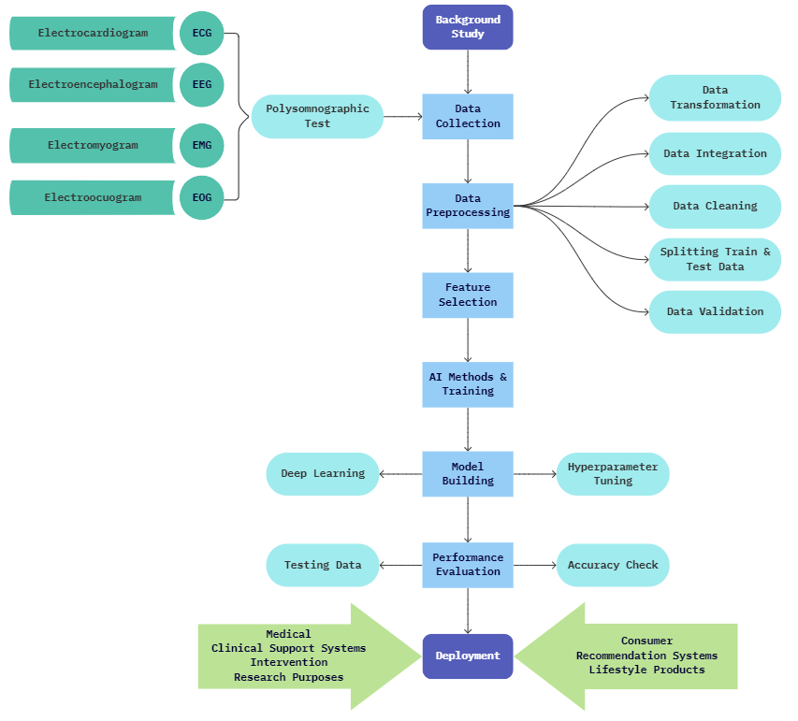

Fig.: Flow-chart of the Process

# References

*Artificial Intelligence and Sleep: Advancing Sleep Medicine.* **Nathaniel F. Watson, Christopher R. Fernandez. 2020.** 2020, p. 51.

*Automatic and Accurate Sleep Stage Classification via a Convolutional Deep Neural Network and Nanomembrane Electrodes.* **Kangkyu Kwon, Shinjae Kwon, Woon-Hong Yeo. 2022.** 2022.

*Learning Sleep Stages from Radio Signals: A Conditional Adversarial Architecture.* **Mingmin Zhao, Shichao Yue, Dina Katabi, Tommi S. Jaakkola, Matt T. Bianchi. 2017.** 2017, p. 10.

*Machine Learning Models for the Classification of Sleep Deprivation Induced Performance Impairment During a Psychomotor Vigilance Task Using Indices of Eye and Face Tracking.* **Matthew S. Daley, David Gever, Hugo F. Posada-Quintero, Youngsun Kong, Ki Chon, Jeffrey B. Bolkhovsky. 2020.** 2020.

*Prediction Models for Obstructive Sleep Apnea in Korean Adults Using Machine Learning Techniques.* **Young Jae Kim, Ji Soo Jeon, Seo-Eun Cho, Kwang Gi Kim, Seung-Gul Kang. 2021.** 2021.

*The future of sleep health: a data-driven revolution in sleep science and medicine.* **Ignacio Perez-Pozuelo, Bing Zhai, Joao Palotti, Raghvendra Mall, Michael Aupetit, Juan M. Garcia-Gomez, Shahrad Taheri, Yu Guan, Luis Fernandez-Luque. 2020.** 2020.